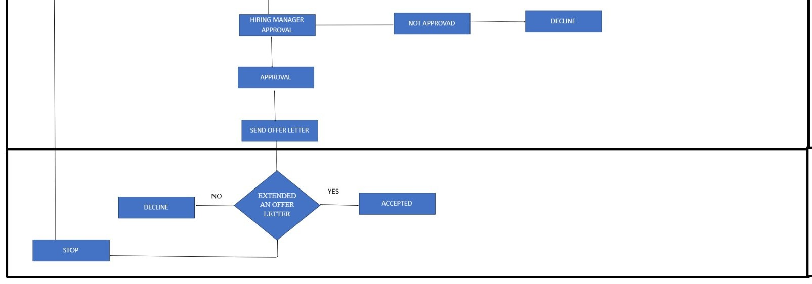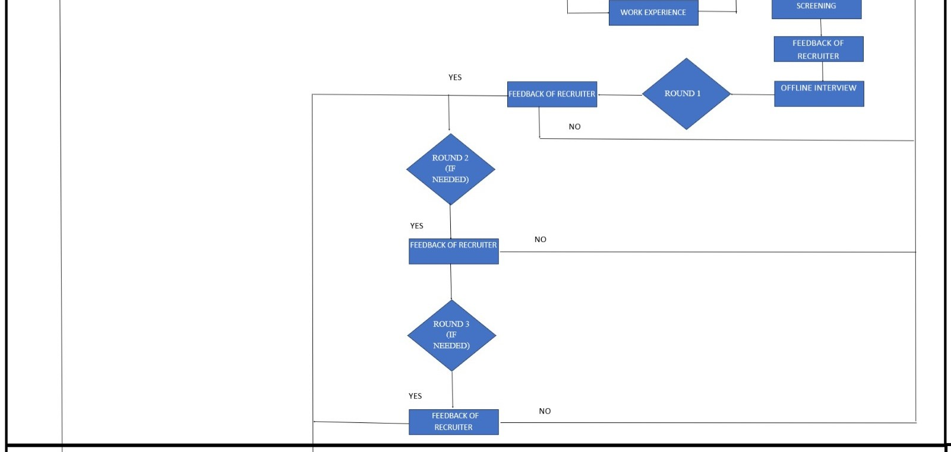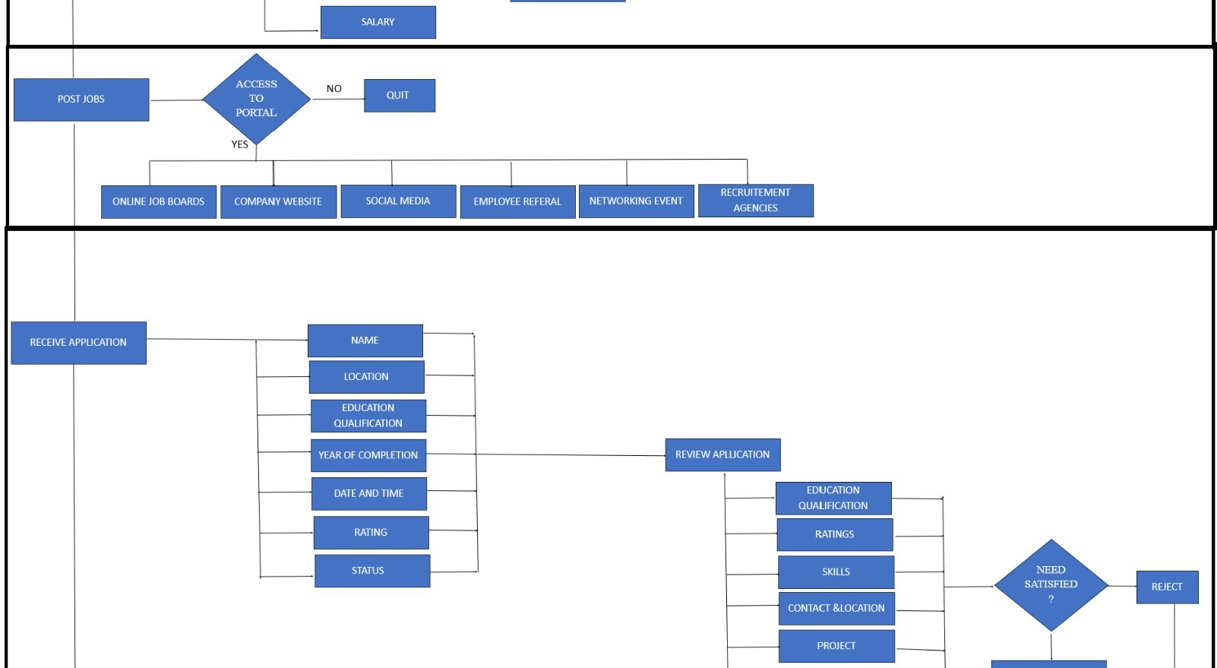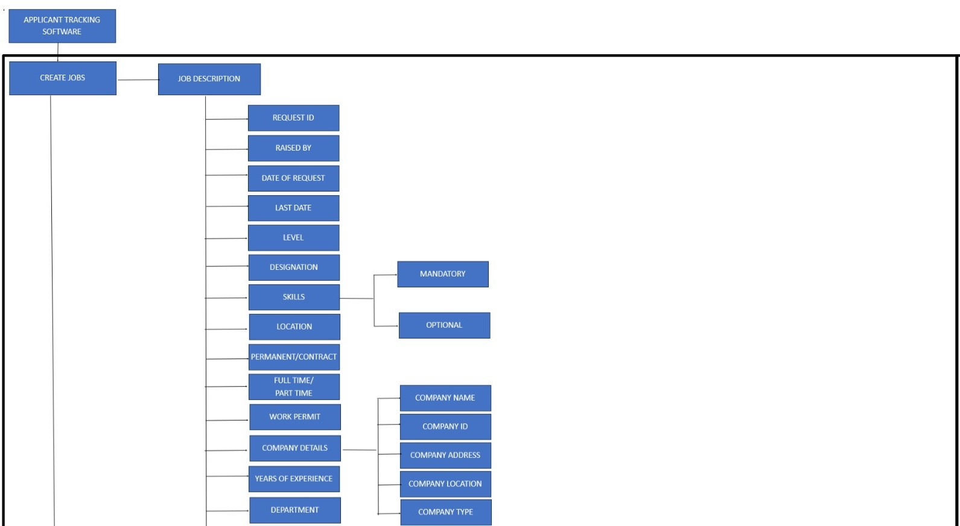

**HR**

**MANAGER**

**HR**

**MANAGER**

**HR TEAM**

**OR**

**MANAGER**

**HR TEAM**

**OR**

**MANAGER**

**HR TEAM**

**OR**

**MANAGER**